# CS 255 System Design Document Template

## UML Diagrams

### UML Use Case Diagram

### UML Activity Diagram – Scheduling an Appointment

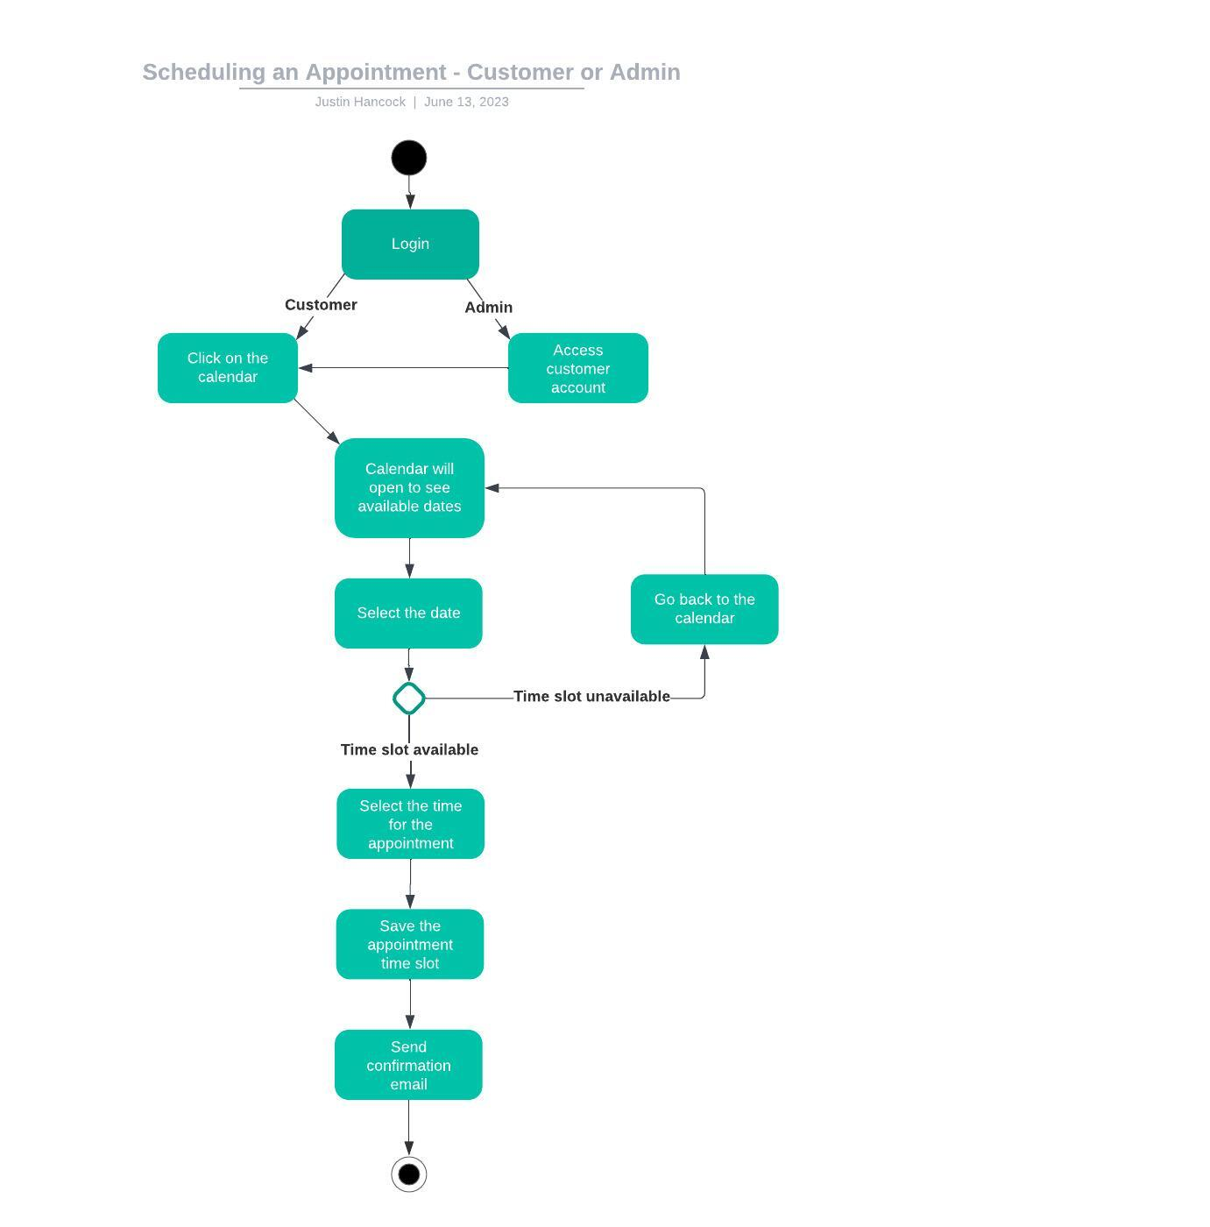

### UML Activity Diagram – Purchasing a Package

### 

### UML Sequence Diagram

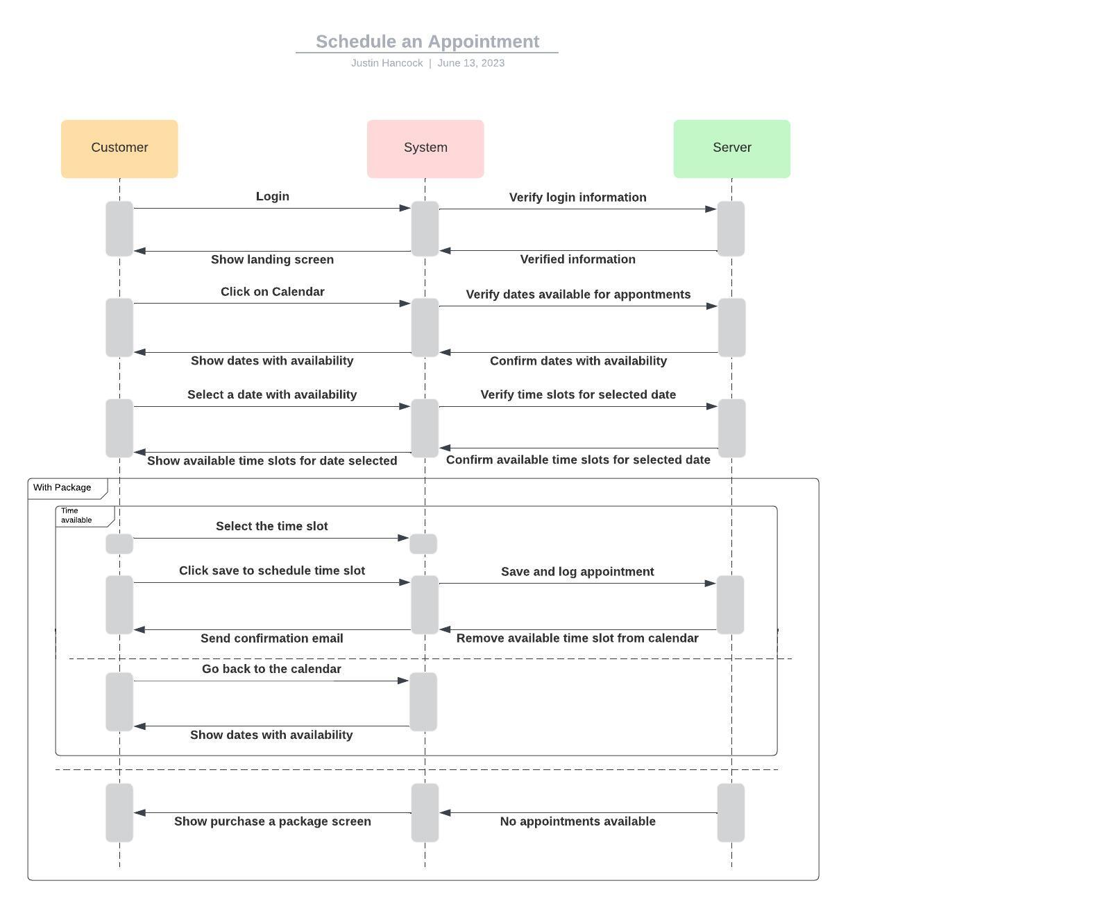

### UML Class Diagram

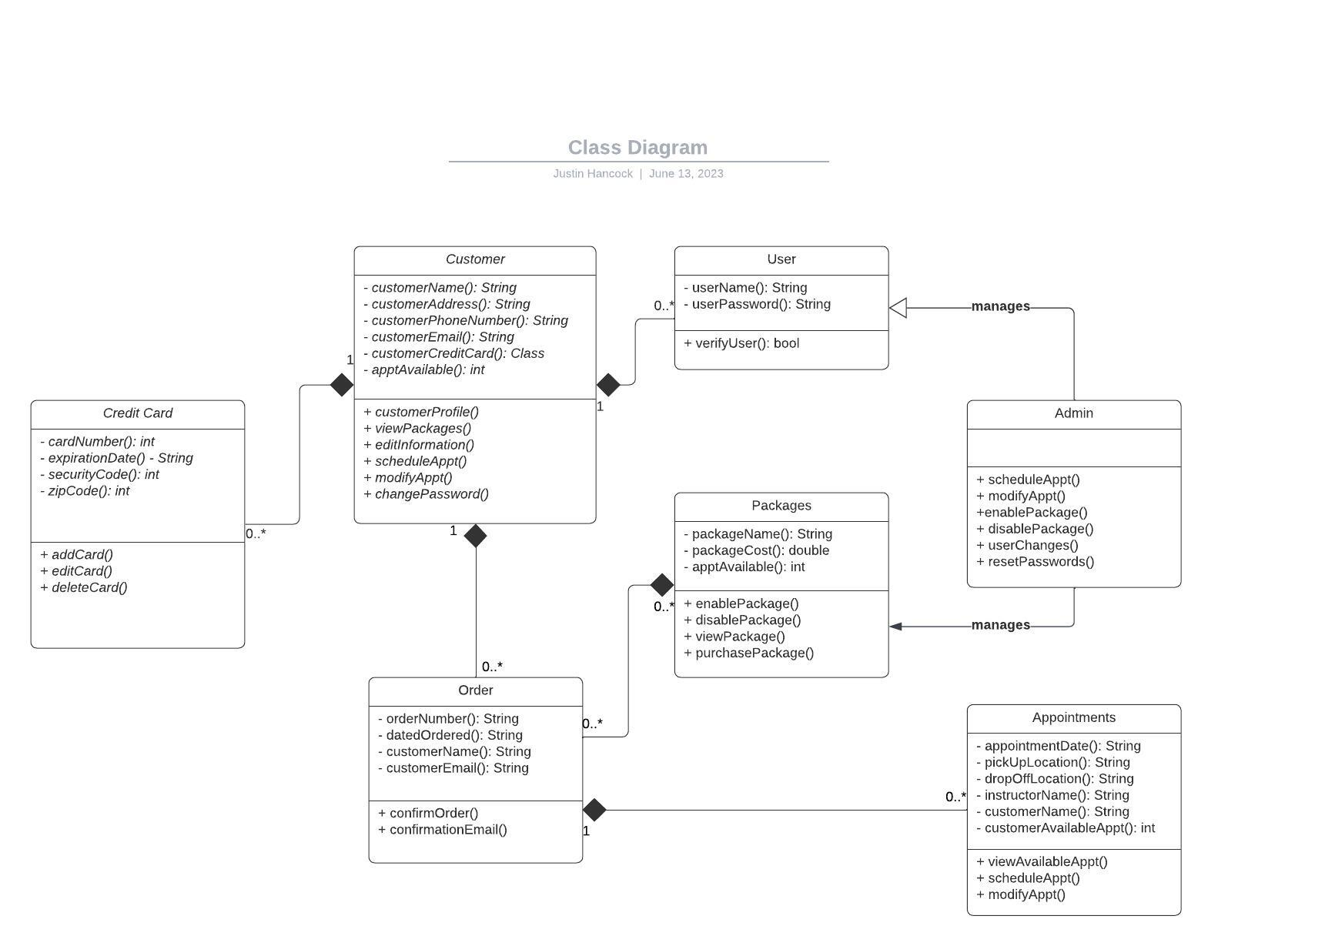

## Technical Requirements

**Hardware needed:**

* Customer must have access to a web browser through a computer, laptop, tablet, or phone.
* DriverPass must have access to a web browser through a computer, laptop, tablet, or phone for their administrator to use.

**Software needed:**

* Web browsers such as: Chrome, Internet Explorer, Edge, Safari, etc.
* Payment processing software.

**Tools needed:**

* Strong internet connection.

**Infrastructure needed:**

* Cloud server database will give the system a better way to stay online with minimal downtime.
* Accessibility of the DMV database to upload new data instantly.
* The ability to translate the website into multiple languages.